**BOOT CAMP 1**

**Data Pipeline for Customer Account Analysis**

This document outlines a data pipeline for processing customer account data, including copying data from a backend team's storage account, performing transformations in Databricks, and upsert data (insert or update) from a file(GOLD Storage) in Azure Data Lake Storage (ADLS) into a dedicated SQL pool table in Azure Synapse Analytics.

**Architecture:**

**Role Title: Data Engineer (ETL & Transformations on Databricks)**

**Role Summary:** As a Data Engineer, I am responsible for developing and maintaining efficient ETL pipelines and data transformations within Databricks notebooks. My primary focus is on processing large datasets, applying complex data transformations, and ensuring data integrity. I leverage Databricks’ capabilities to optimize workflows, enabling seamless data integration across various sources. Additionally, I manage secure access by providing necessary access tokens, ensuring that team members and stakeholders have the appropriate permissions to interact with the data. I play a crucial role in building a robust data processing framework for the organization.

Backend data with all the required data has been created

Using Get metadata and for each activities, copying the backend data to raw-bronze layer

Files has been successfully reflecting in raw-bronze layer

App created for service principle, application ID and Directory ID

Secret scope has been created with data bricks instance

Data bricks instance has been created with the secret keys   
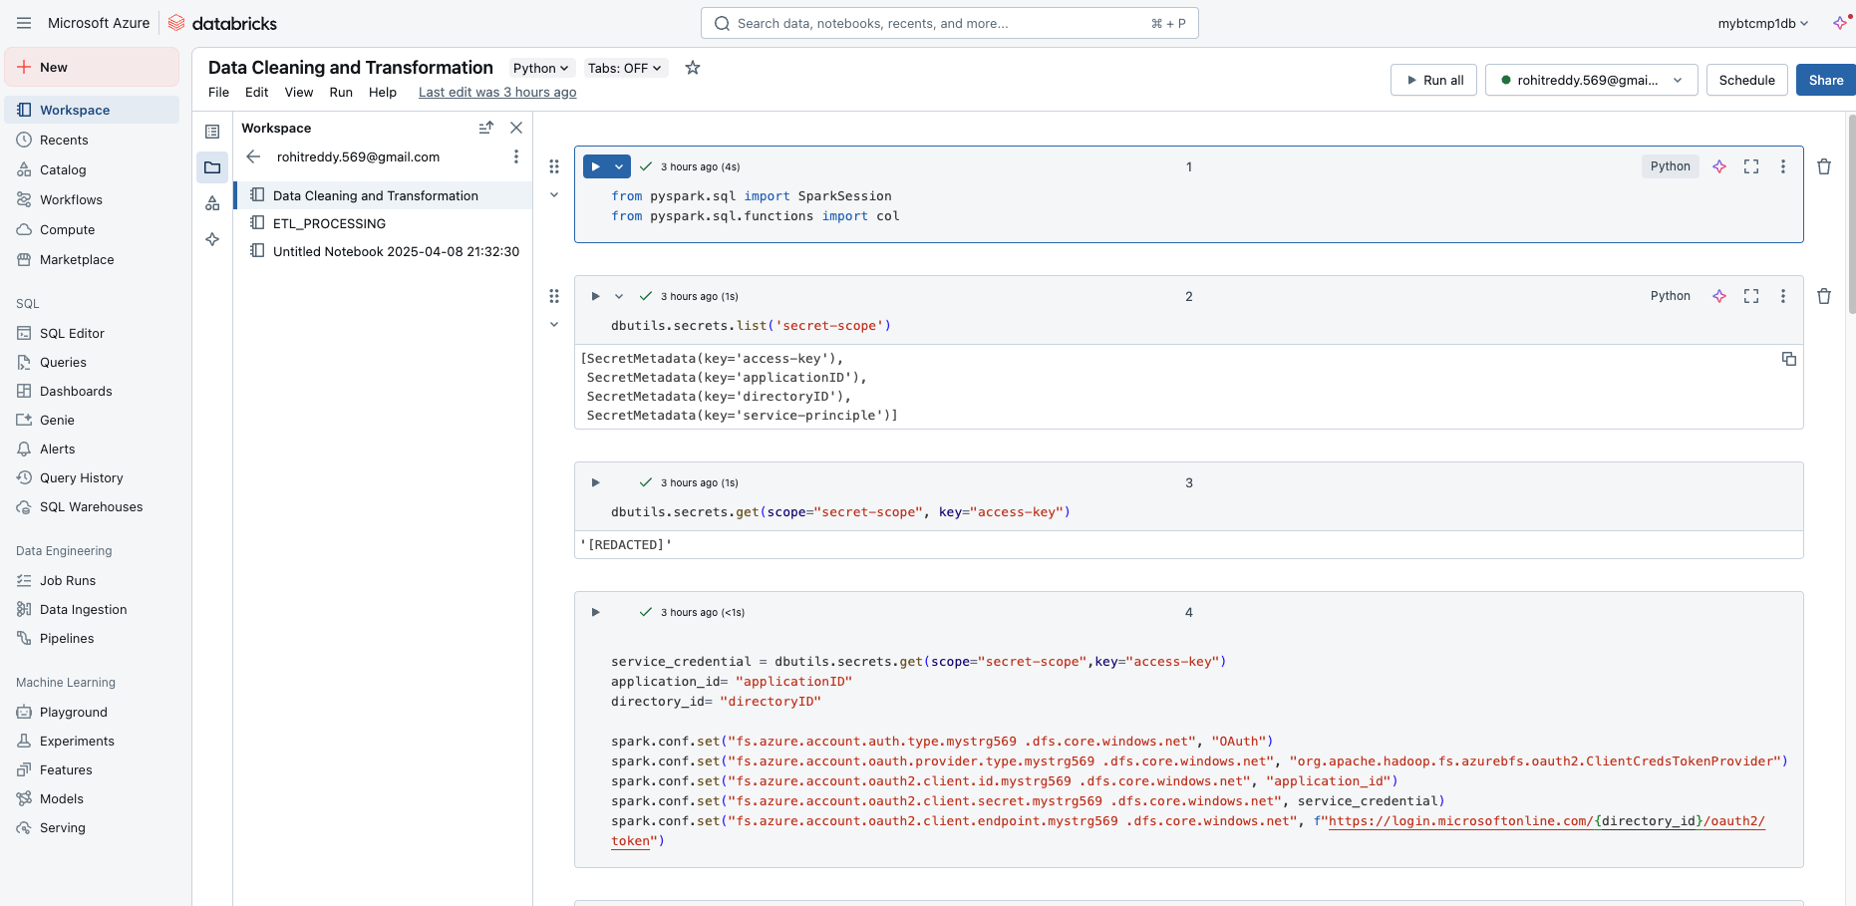  
Data cleaning and transformation in Data bricks

Writing the cleaned data to Silver layer

Files has been created after the pipeline run in silver container

ETL Processing in Data bricks

Got the curated data and writing it to gold layer

New file has been created in parquet format after the pipeline run

External tables have been created in synapse analytics   
Pipeline in ADF has been successfully completed and data can be seen in synapse analytics

If total balance of all customer id’s are required

If balances of specific Customer Id is required

